**PHAN HUY KHÁNH – 22IT.B107 – LAB 3 – EX 5-1**

1. Start the Chrome browser and run the application in the ex_starts/ch05_ex1 directory. This should display the menu that lets you navigate to the Product Manager application or the Product Catalog application.

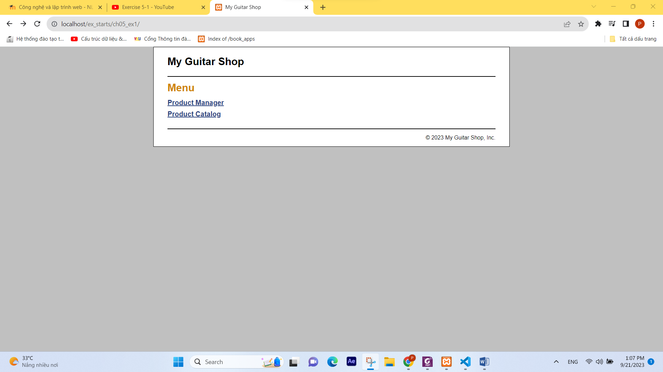

1. Use the Product Manager application to add a new product to the database with Guitars as the category, test1 as the code, Test Product 2211 as the name, and 550.00 as the list price.

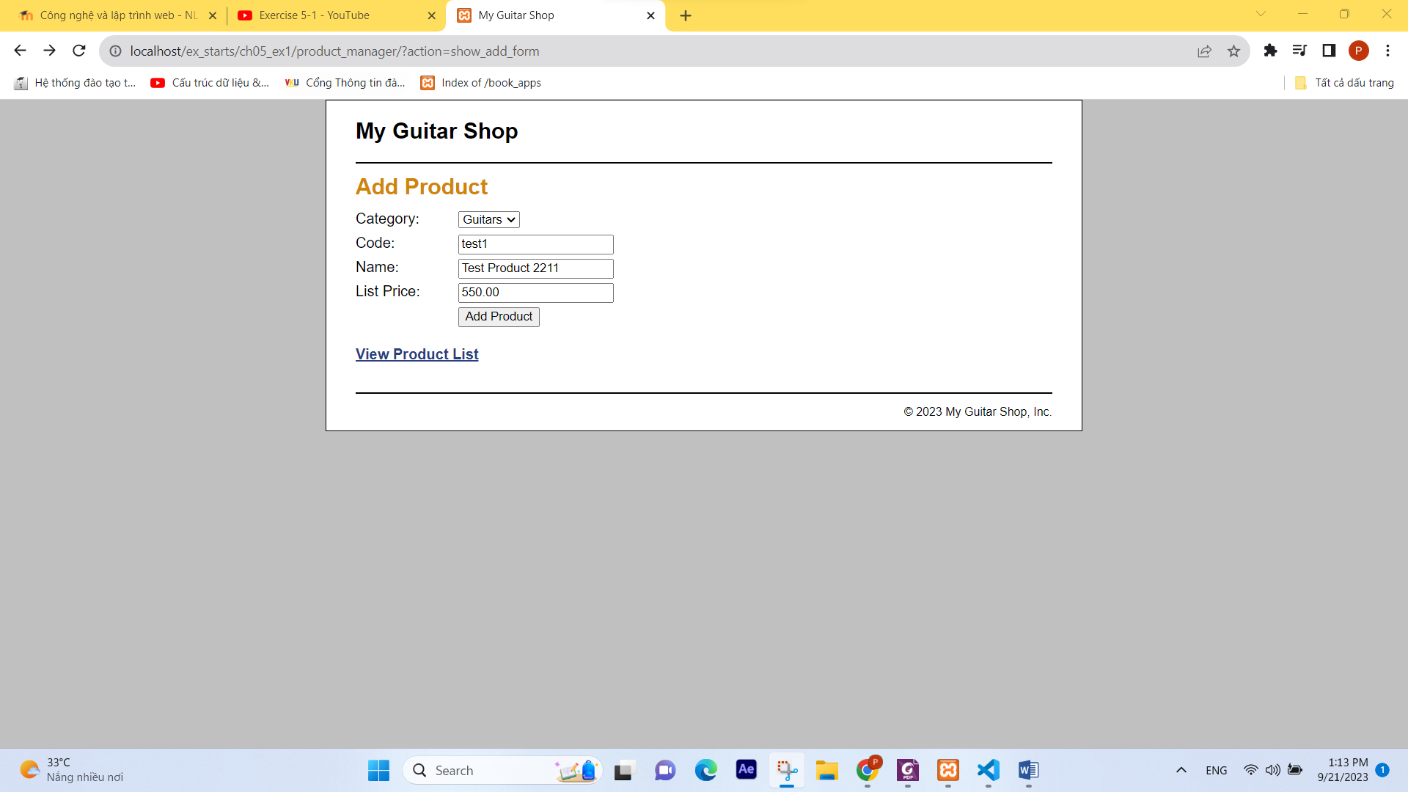

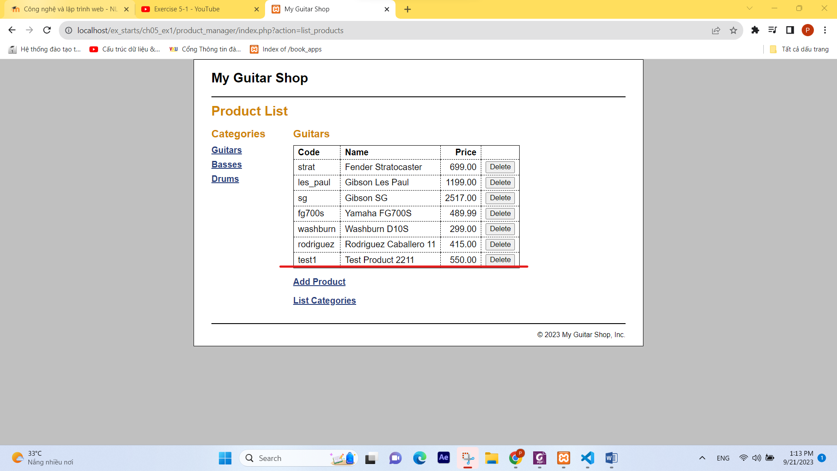

1. Go to the Product Catalog application. Then, view the product that you just added. Note that it doesn’t display an image for the product. To fix that, go to the image directory and change the name of test.png to test1.png.

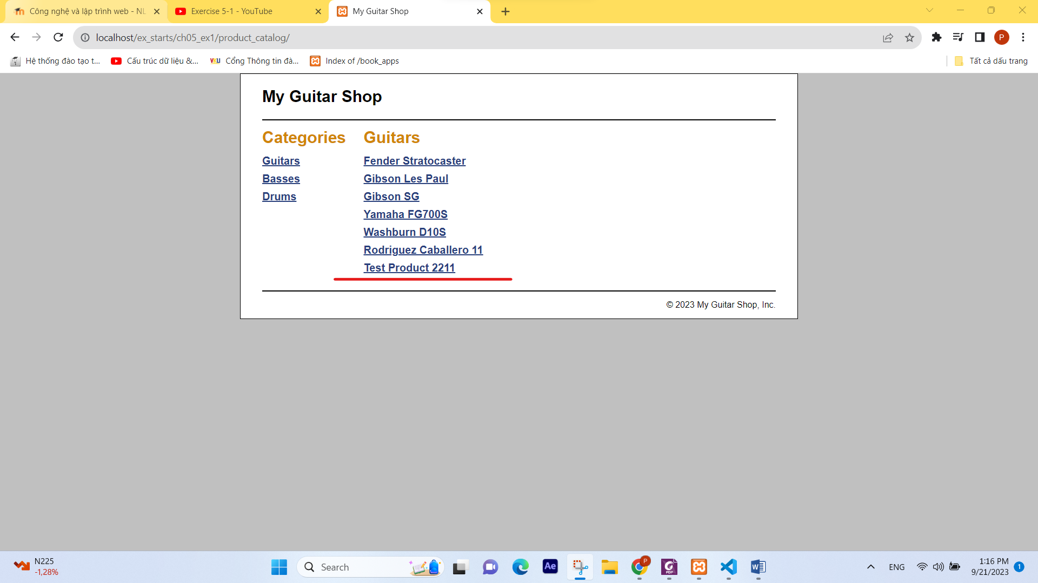

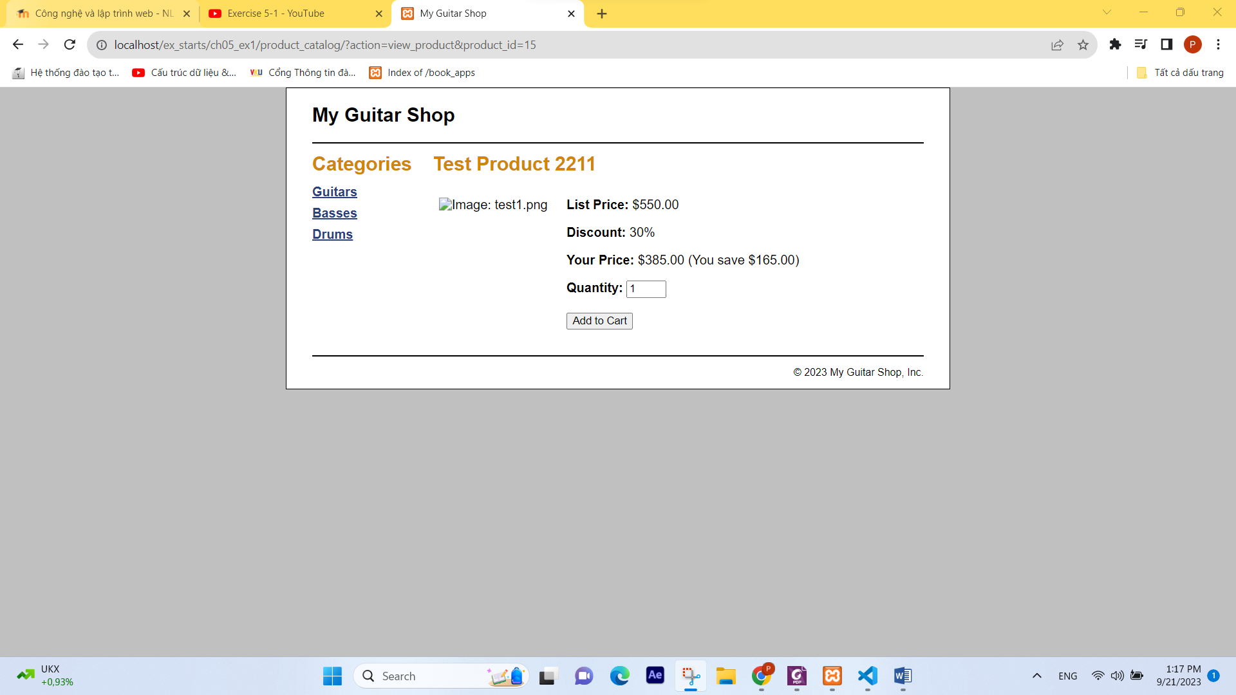

Result:

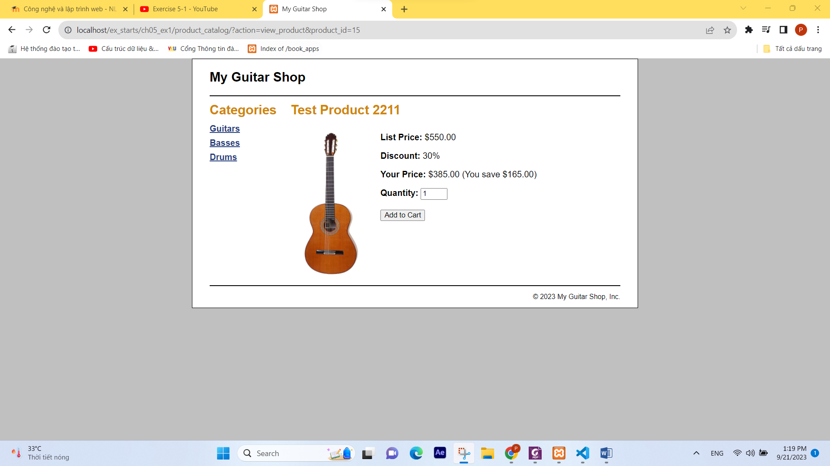

1. Go to the Product Manager application again. Then click on the List Categories link at the bottom of the page. Note that this link doesn’t display a page, even though it is coded correctly. You’ll fix this later when you enhance the index.php page for this application. Now, click the Black button.

